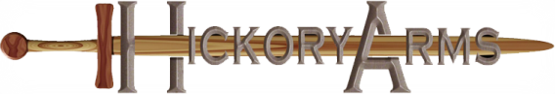
Custom Order Instructions
Thanks for interest in a custom Hickory Arms sparring sword!
Name of Sword:
Please give a detailed description of what you envision. Provide us with images, sketches, and measurements of your intended custom piece.
Costs and time to make your custom sword will depend on difficulty of the piece, size, and whether it will be used for contact sparring. Your cost may include estimated design time, prototype development, production time, alteration time and finishing.
Once all the details are agreed upon your order can take from 4 – 12 weeks.
Here is the information we need!

Customization of an Existing Hickory Arms Sword
Give specific details, what is being altered:

Dimensions – Overall length, handle length, blade length, width of blade and guard

Engraving
Please attach any pictures or sketches

All New Custom Sword
Describe detailed request:

NOTES (leave blank)

Dimensions – Overall length, handle length, blade length, width of blade and guard

NOTES (leave blank)

Engraving
Please attach pictures and sketches
Will the sword be used for sparring?
When is your custom sword needed?

Estimate for Customization (leave blank)
Cost | Units | Cost | Total
Design hours ($50/hr)
Cost of Sword
Engraving
 |  | Grand Total
Time Estimate for completion

Approval to be signed once all details are agreed upon
I approve the custom work.
Signature:
Contact Information: Name, Address, Email, Phone

Work will begin with payment of approved invoice.

